

**CRIME DATA MANAGEMENT SYSTEM FOR THE OFFICE OF THE VICE-MAYOR**

**A Capstone Presented**

**To the Faculty of the College of Business**

**Administration, Silliman University, Dumaguete City, Philippines**

**In Partial Fulfillment of the Requirements of the Course**

[**BA-AN 34P (2018)-A (LEC) Thesis/Capstone**](https://soul.su.edu.ph/course/view.php?id=19605)

**By:**

**Amil, Derrick Thomas**

**Andres, Shekinah T.**

**Felisilda, Josemaria Archel G.**

**Geslani, Daniela U.**

**Lituañas, Eunice Mel G.**

**Serilo, Nikka Marae Leonore V.**

**Crime Data Management System**

***Purpose***

The purpose of the crime data management system is to provide the office of the vice mayor with a centralized data visualization system which they can use and suited for their system’s structure. Among others, this system has components such as types of crimes, time and date, locations, which are based on police records and plotting them dynamically. The data that will be used for this system are the criminal case records and statistics provided by the Dumaguete City Police Station.

***Project Objectives***

1. To identify the number of criminal cases in each community of Dumaguete City through the use of data visualizations, specifically heat maps and charts.
2. To assist our government leaders and law enforcement officers in identifying patterns of criminal cases.
3. To raise awareness on the given types of criminal acts that most frequently occur in typologically similar parts of the community.
4. To establish a baseline analysis and formulate models that are suited to the system’s structure.

***Data Sources:***

Available public records and statistics obtained from the Dumaguete City Police Station

***Data Gathering options***

Initial Data Gathering

1. Meeting with the Police Officer-in-Charge.
2. Regular communication with the personnel in charge of the data records.

Post Data Gathering

1. Create a page/system for the office of the vice mayor that is suited to their structure.
2. Taking into account the “how might we’s” with the problems and patterns we’ve already identified while gathering data.

***Possible Benefits and Beneficiaries of the Insights out of the data***

Mainly, the insights taken out of the data helps to improve the performance of the police and is used as an input for decision-making processes within the community. The advantage of using visualizations becomes apparent when communicating the information to the office.

Data visualization is increasingly important for operations for police and other agencies of the criminal justice system. It is also an important tool for teaching and explaining data analysis to our target audience (which are the Dumaguete City barangays/police stations). It provides them security since we are showing the current state of their barangay, regarding the intensity of crime experienced.

The more officers who can view the larger picture, the more likely it is that a crime will be solved quickly. We offer our skills in bringing out a project related to data visualization such as identifying locations and plotting them dynamically based on criminal case records that are made available to your community. The concept is starting to gain traction and the community is becoming more accustomed to this type of approach. The shift in focus inside agencies from solving crimes to preventing them is contributing to this trend. This is for the police practice for investigation, crime prediction, and planning of police forces. This would not only benefit the police but also the people in the community.

***Video Link***

This video provides our first presentation about crime data visualization in excel for the office of the vice mayor.

<https://drive.google.com/file/d/1H8xExzyWy0pMpW3aAYBssn_QWQ1C7_x7/view?usp=sharing>

***Project Status Report***

Gantt Chart link: [CRIME_DATA_VISUALIZATION_GANTT_CHART.xlsx](https://docs.google.com/spreadsheets/d/1S7HLWcOKwmxkTlc1CS60dfqOkCSEY2ka/edit?usp=sharing&ouid=115487264287296143375&rtpof=true&sd=true) ***(version 1)***

[***https://drive.google.com/file/d/12DnVnyNsNnbvZ6ZzyVStycCoBn-L78Ex/view?usp=sharing***](https://drive.google.com/file/d/12DnVnyNsNnbvZ6ZzyVStycCoBn-L78Ex/view?usp=sharing) ***(updated gantt chart)***

***Screenshots of the Gantt Chart:***

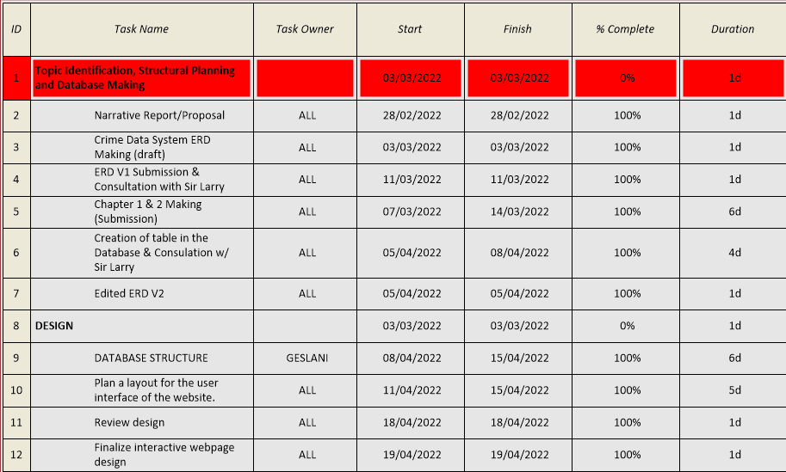

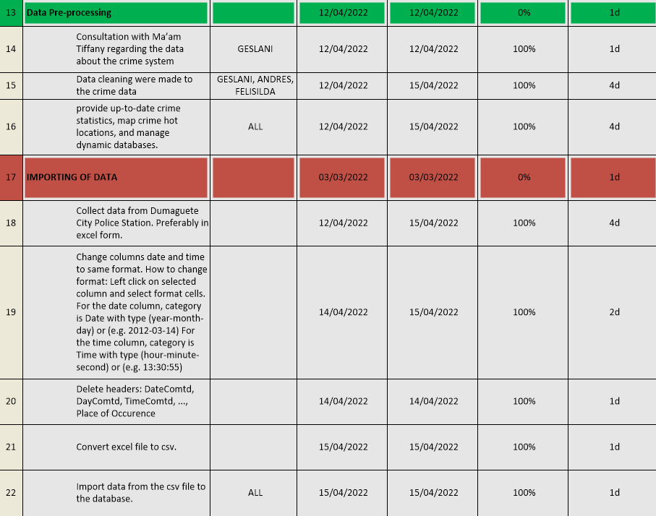

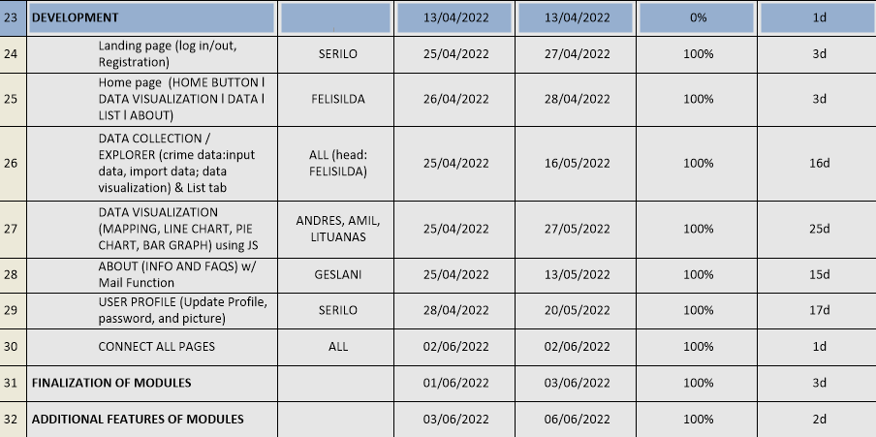

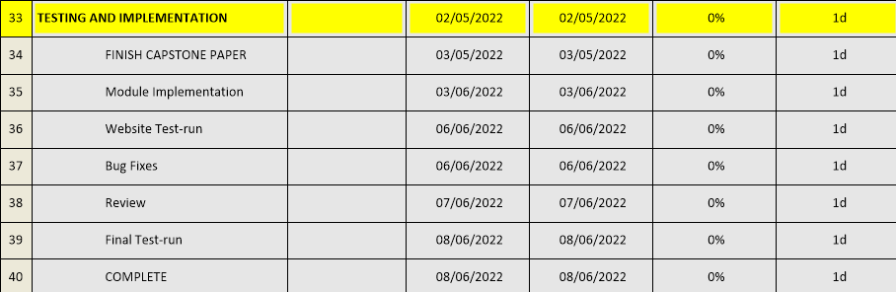

***Documentation*** 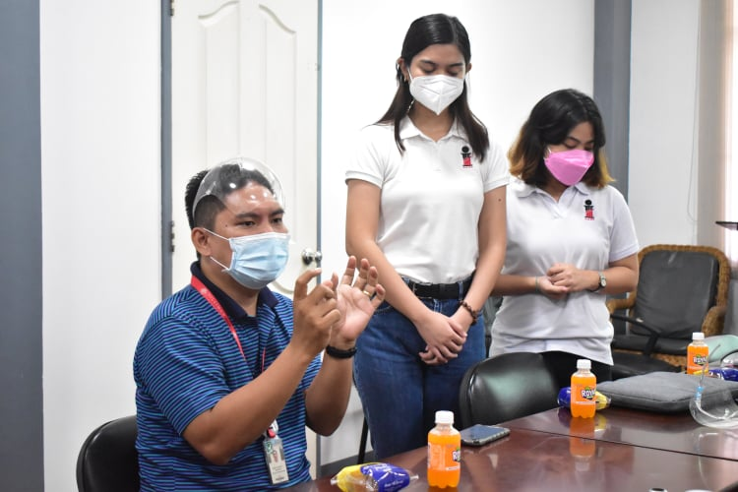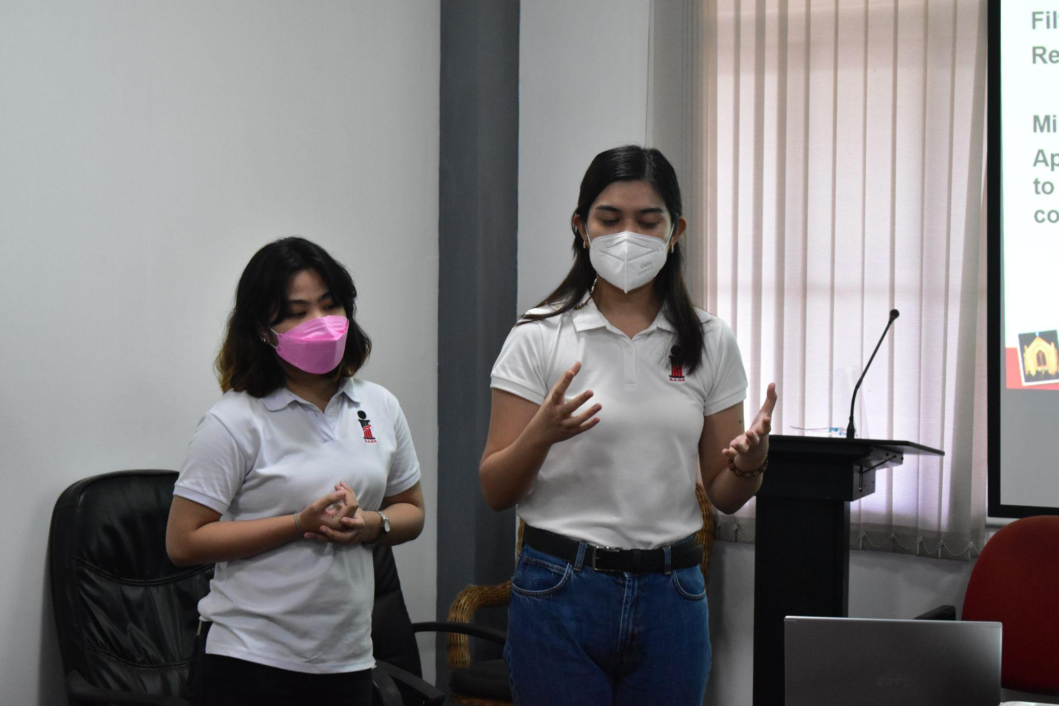

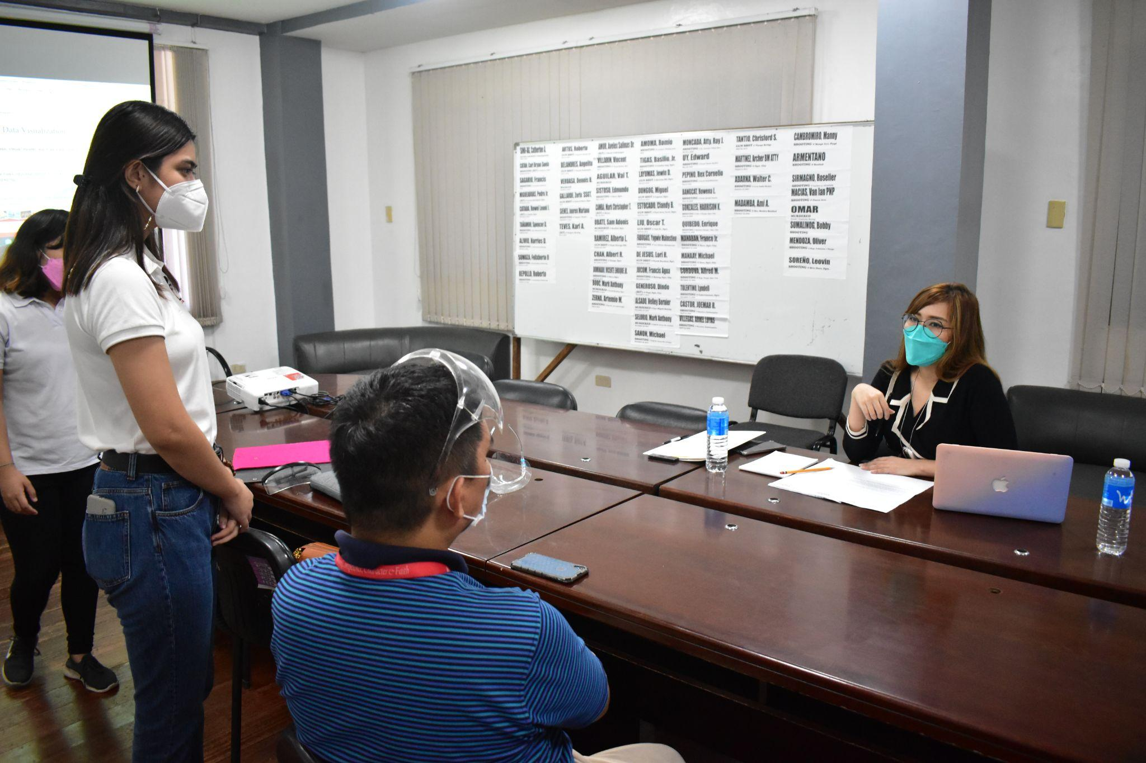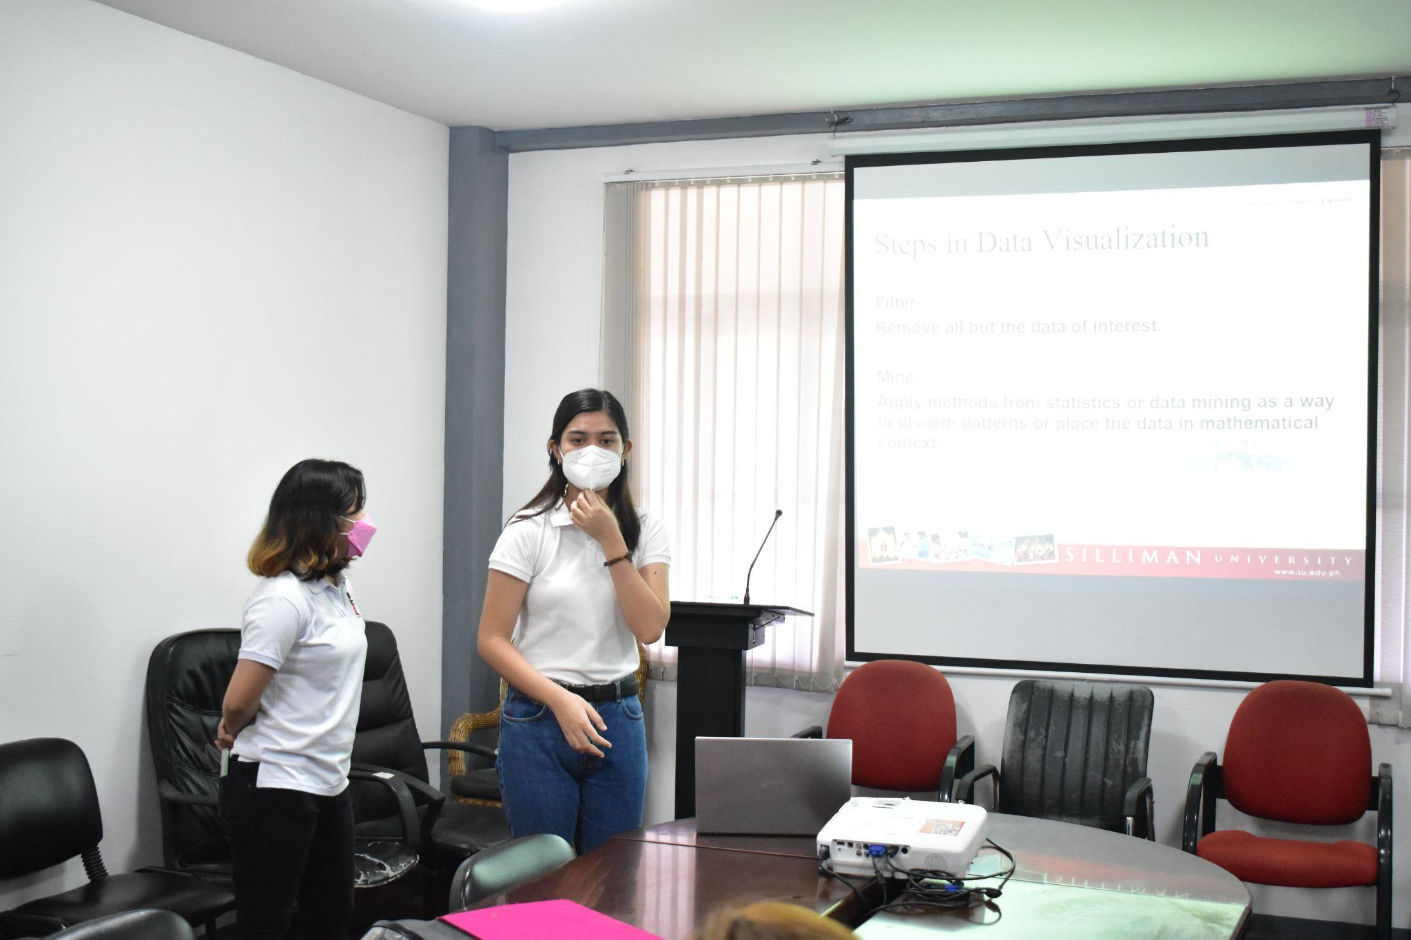

Date: November 15, 2021

Location: Dumaguete City Hall

Agenda: Meeting with the Vice Mayor of Dumaguete City

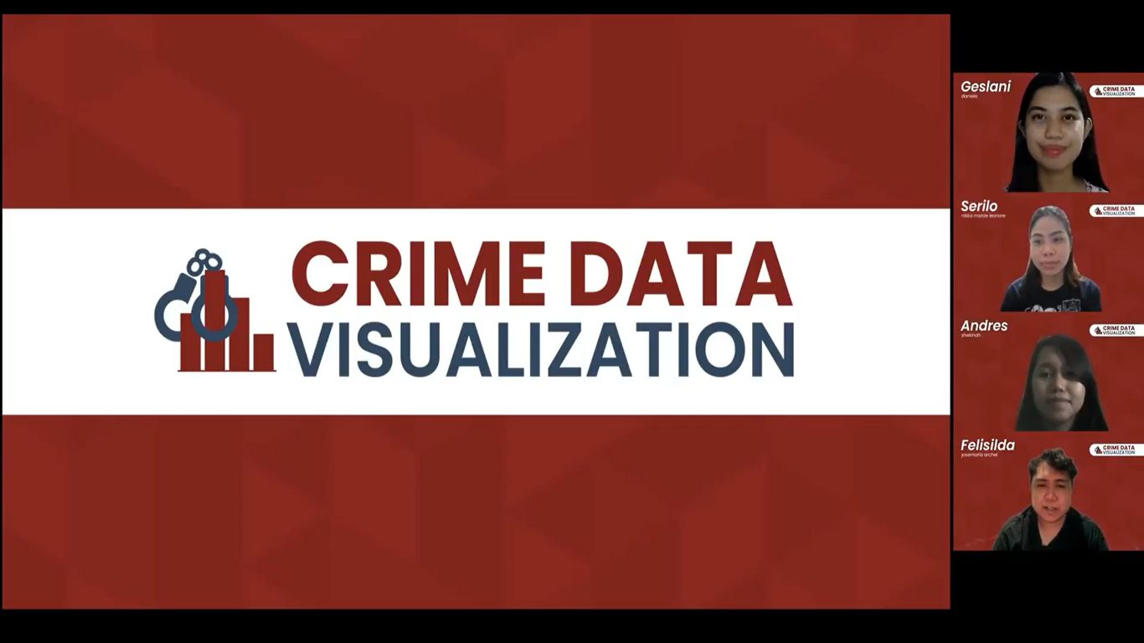

Date: January 9, 2022

Location: Zoom Meeting

Agenda: Recording of the presentation

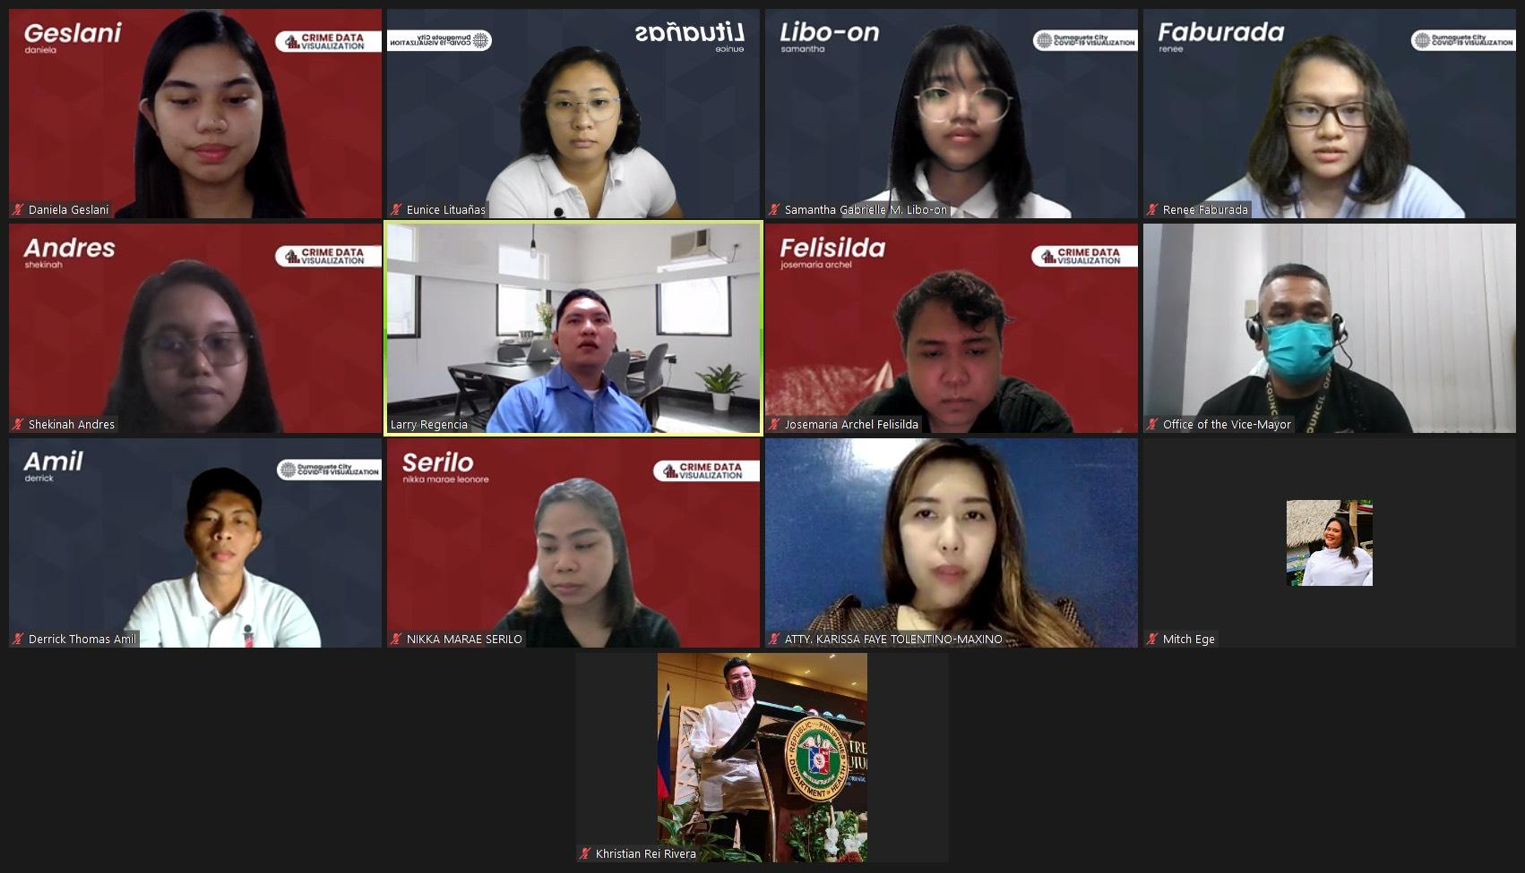

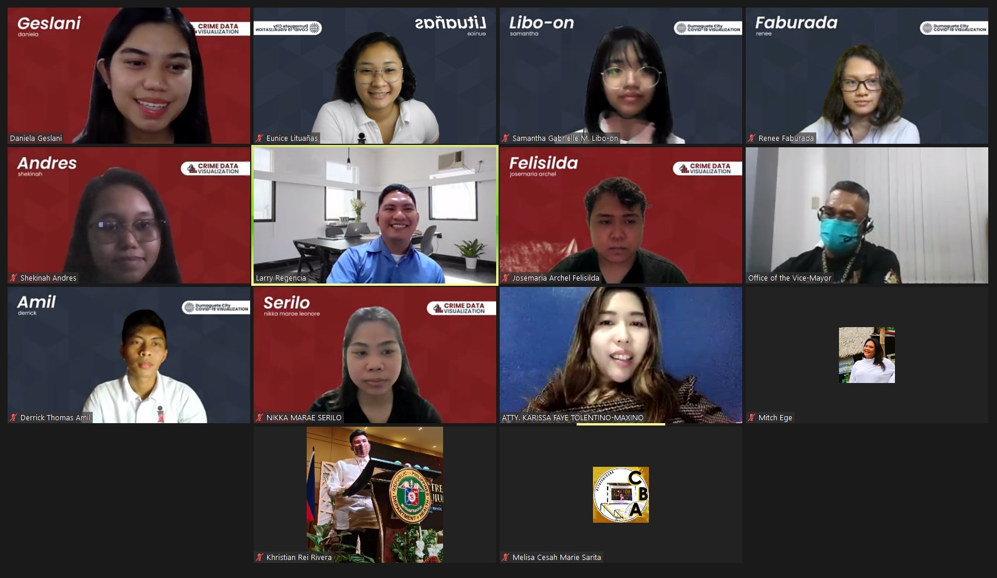

Date: January 13, 2022

Location: Zoom Meeting

Agenda: Presentation with Attorney Karissa Faye R. Tolentino-Maxino

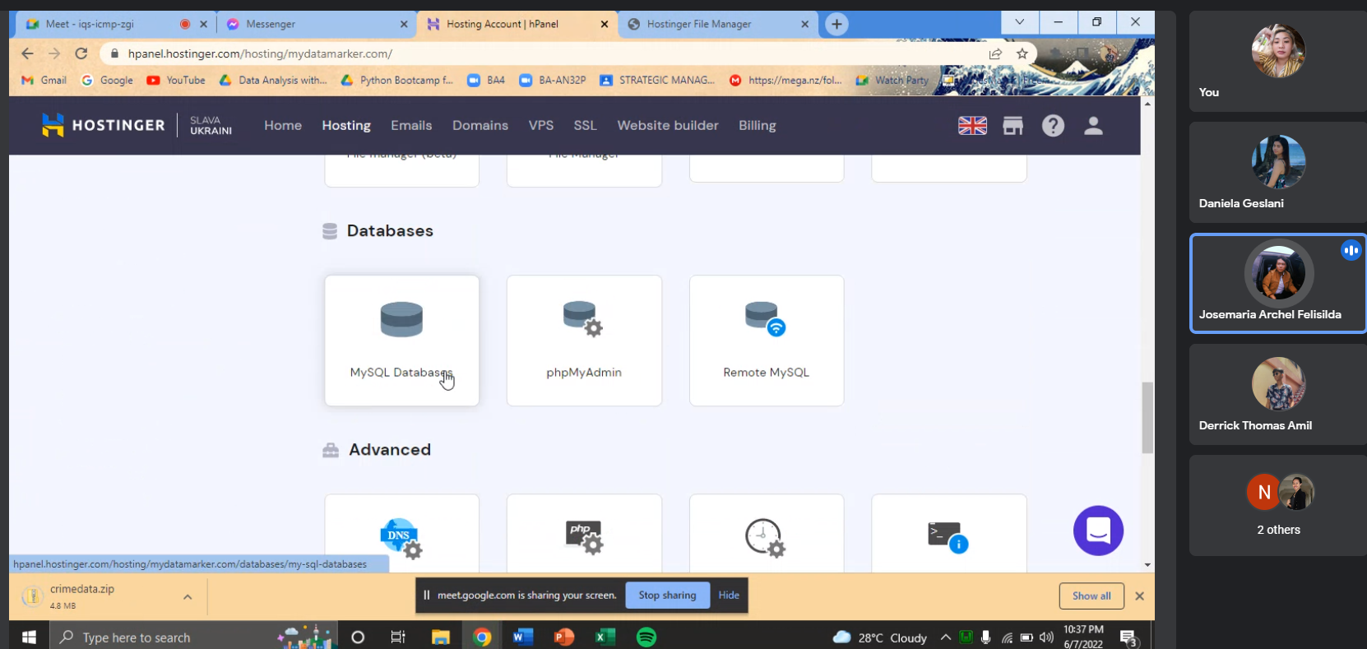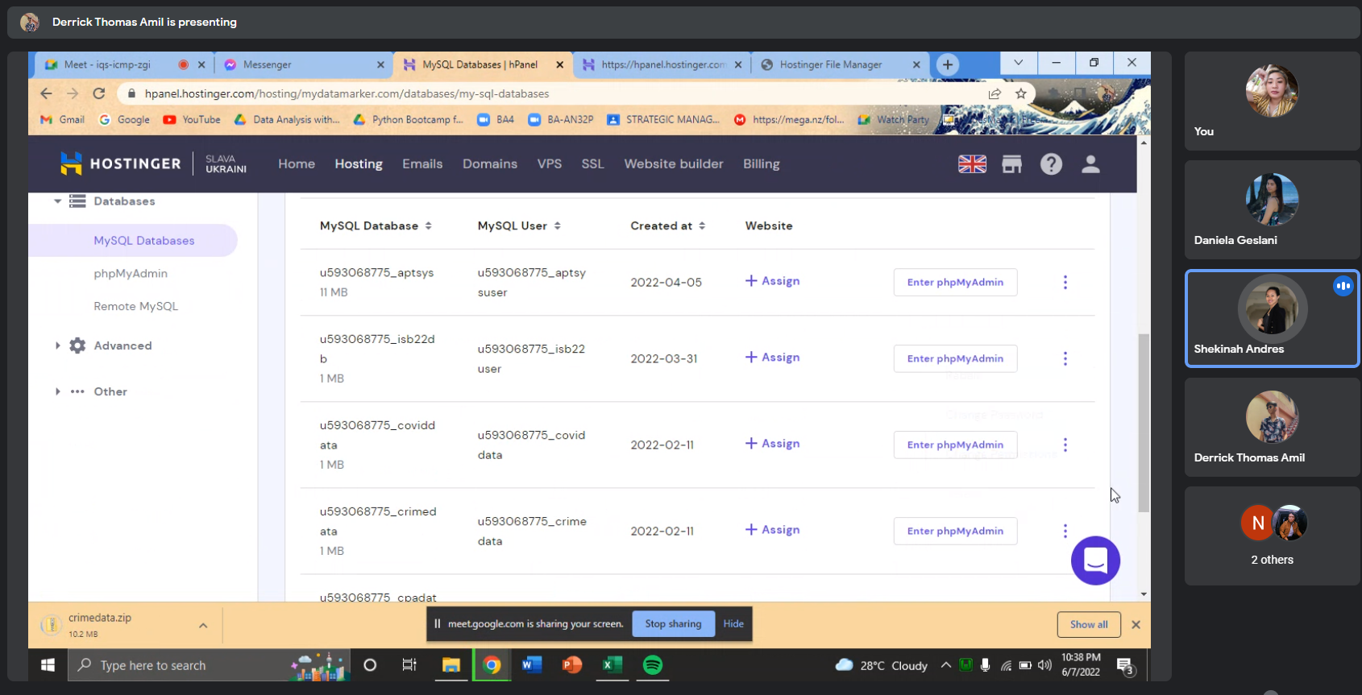

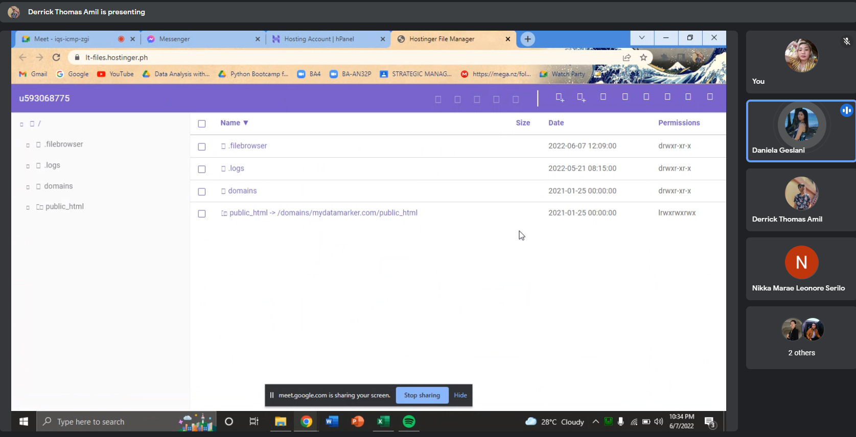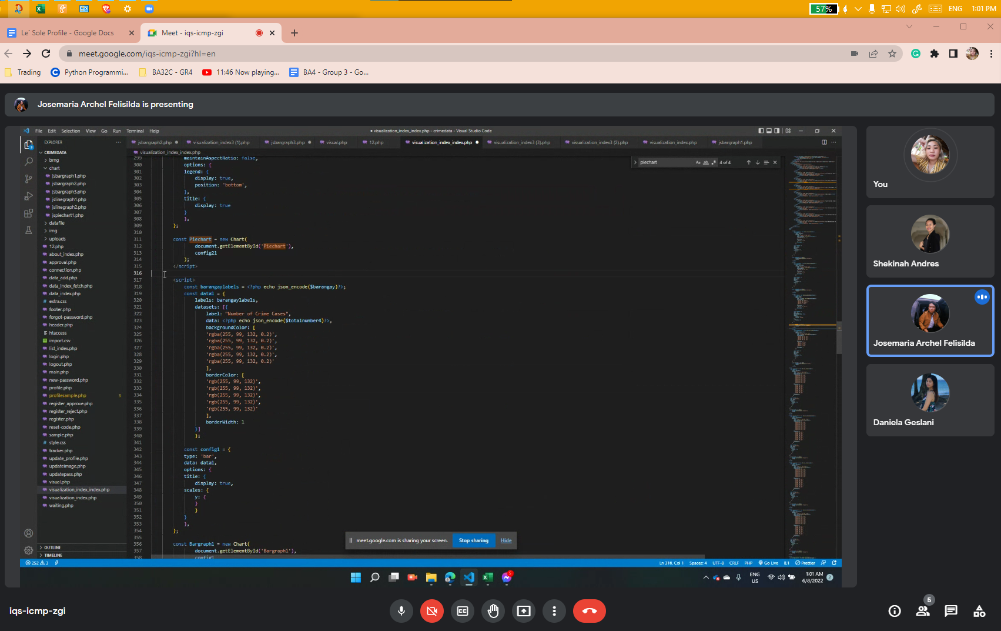

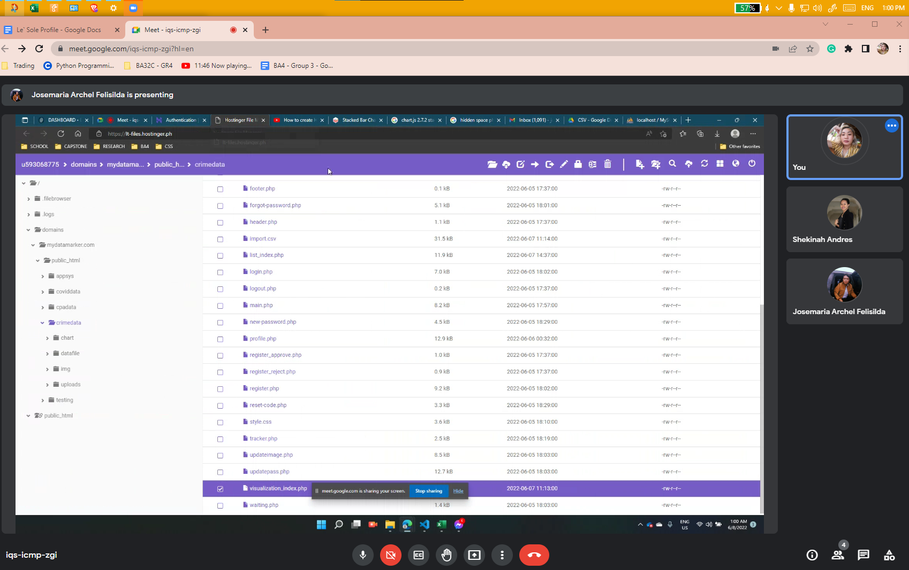

Agenda: Planning and meeting about our developments with the group (through google meet)

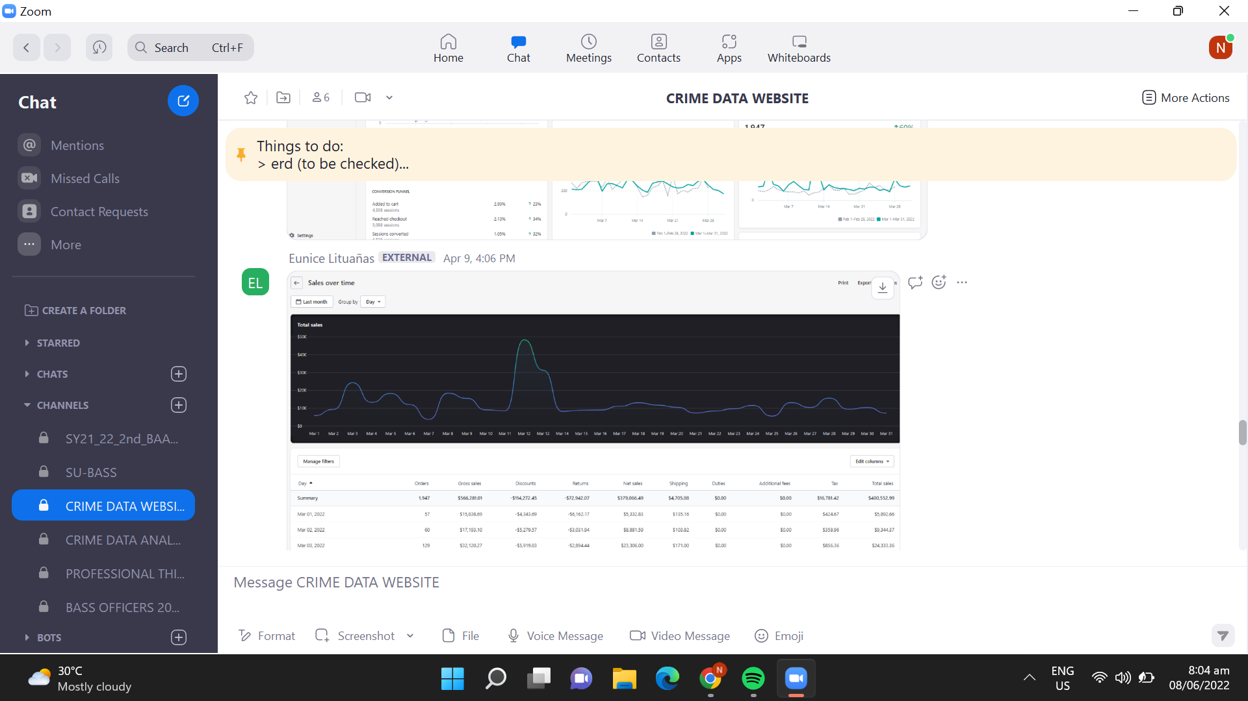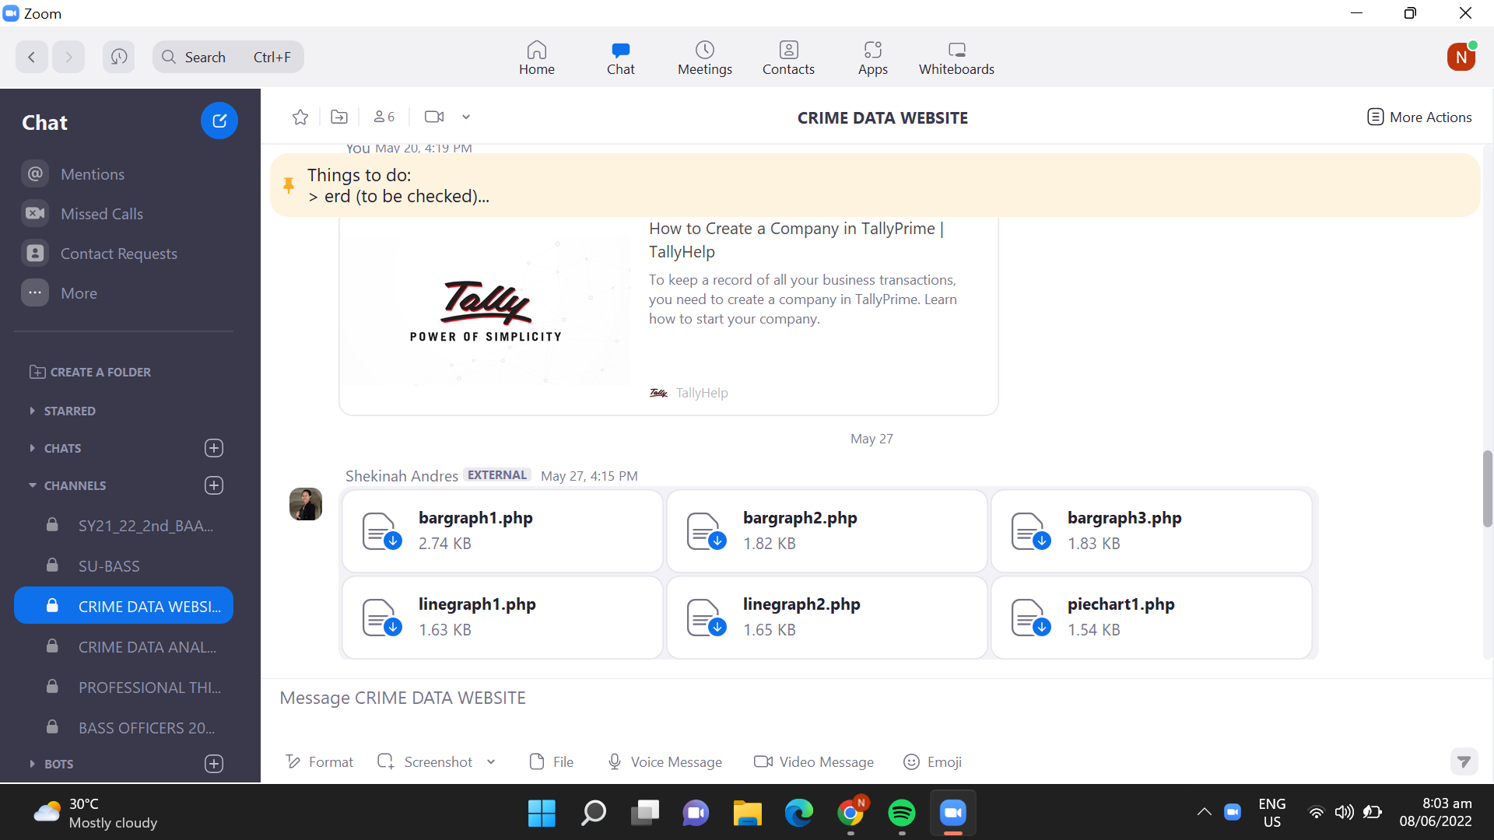

Agenda: Important reminders and files shared from our group chat, we communicate using zoom, messenger, and meet through google meet.

**SCHEDULE OF MEETING:**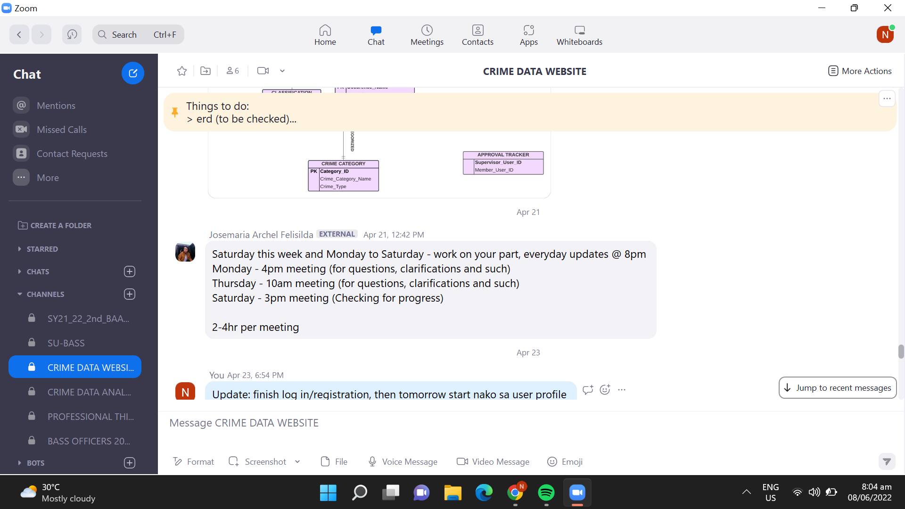

FOR OUR WEB PAGE since we cant meet each other in person yet: 